* The DATEADD function is used to add an interval to a date.

SELECT DATEADD (day, 10, '2000-01-05 00:05:00.000');

**Output :'2000-01-15 00:05:00.000'**

In this example, we are adding 10 days to the original datetime.

datepart can be one of the following:

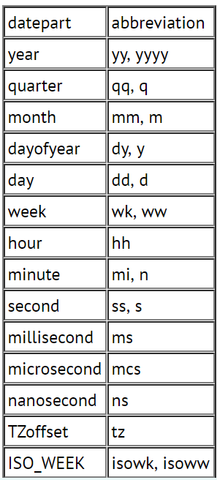

* **DATEDIFF Syntax in MySQL**

**SELECT DATEDIFF (month, '2000-01-31 23:59:59.000','2000-02-01 00:00:00.000');**

produces the following result:

**1**

Even though the actual difference between the two datetime values is 1 second, the **DATEDIFF** function returns 1 when we ask for the difference in months. This is because SQL Server only compares the year and month fields. All other fields (day, hour, minute, second, milisecond) are ignored.

# **SQL HAVING Clause**

* HAVING filters records that work on summarized GROUP BY results.
* HAVING applies to summarized group records, whereas WHERE applies to individual records.
* Only the groups that meet the HAVING criteria will be returned.
* HAVING requires that a GROUP BY clause is present.
* WHERE and HAVING can be in the same query.
* **SELECT COUNT(Id), Country**
* **FROM Customer**
* **WHERE Country <> 'USA'**
* **GROUP BY Country**
* **HAVING COUNT(Id) >= 9**
* **ORDER BY COUNT(Id) DESC**
* **SELECT AVG(TotalAmount), FirstName, LastName**
* **FROM [Order] O JOIN Customer C ON O.CustomerId = C.Id**
* **GROUP BY FirstName, LastName**
* **HAVING AVG(TotalAmount) BETWEEN 1000 AND 1200**